18.03.2025

Krzysztof Smykla

**Lab 1 Report**

**Problem 1 – Unit Impulse Function δ*[n]:***

The problem consisted of graphing the discrete-time unit impulse function and the unit step function u[n] using built-in MATLAB functions *ones()* and *zeros().* The specified domain for both functions was **n ∈ [-10,10]**.

**1b:**

Modifying the code provided in the description I generated the function **δ[n - 2]**using the built-in MATLAB function *circleshift()* which circularly shifts the elements in array A by K positions.

(MATLAB documentation: [https://uk.mathworks.com/help/releases/R2024b/MATLAB/ref/circshift.html](https://uk.mathworks.com/help/releases/R2024b/matlab/ref/circshift.html) )

See MATLAB code below:

 % Exercize 1

% P1a

% generate the signal delta[n] and plot it

clc,clearvars

n = -10: 10; %values of time domain

delta_n = [zeros(1,10), 1, zeros(1,10)];

%b

figure(1)

stem(n, circshift(delta_n, 2), LineWidth=1); % delta impulse shifted circularly by 2

axis([-10, 10, 0, 1.5]);

title('Unit Sample Function');

xlabel('Time index n');

ylabel('delta[n]');

The code provided generates the modified unit impulse function and shifts it by a vector *v*[2,0].

Fig. 1:

**1c:**

In point c the task was to create the unit step function u[n] also using the ones() and zeros() functions as before on the range **n ∈ [-10,10]**.

%c

figure(2)

u_step = [zeros(1,10), 1, ones(1,10)];

stem(n,u_step,LineWidth=1); % unit step function plot

axis([-10, 10, 0, 1.5]);

title('Unit Step Function');

xlabel('Time index n');

ylabel('U[n]');

The code generates the function and plots it on a separate figure.

Fig. 2:

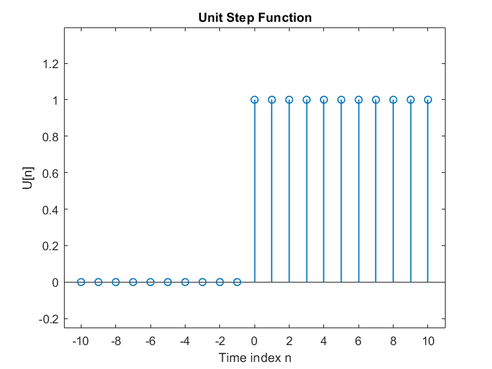

**1d:**

In point d I was asked to generate a plot for the function U[-n-3].

MATLAB code is provided below:

%d

figure(3)

stem(n, circshift(-u_step, 3), LineWidth=1); % unit step shifted by v[3, -1]

axis([-10, 10, 0, 1.5]);

title('Unit Step Function 2');

xlabel('Time index n');

ylabel('U[-n - 3]');

Fig. 3:

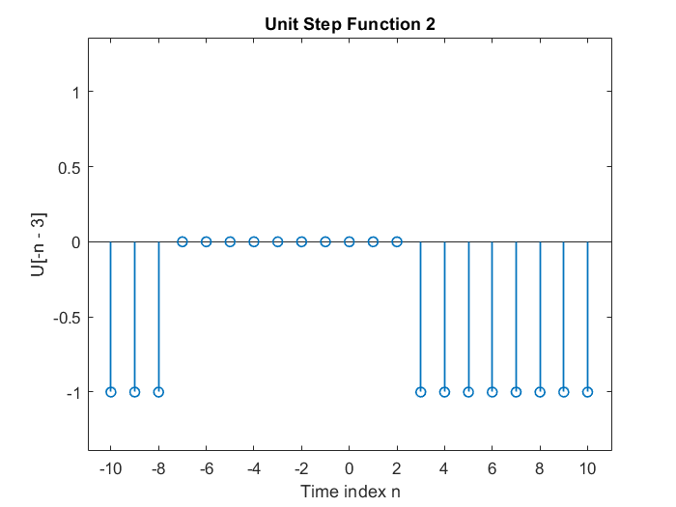

**Problem 2 – Cosine signal (discrete-time):**

Problem 2 asks to generate a discrete-time cosine signal, plot said signal and analyze the signal’s fundamental period. The problem also asks to describe the use of the *grid()* function in MATLAB.

**2a:**

Generate and plot a discrete-time cosine signal.

The code below is the solution for part ‘a’ of the problem as provided in the problem description.

 % P2a

% generate and plot a discrete-time cosine signal

clc, clearvars

n = 0:40; % values of the time variable

w = 0.1*2*pi; % frequency of the sinusiod.

phi = 0; % phase offset.

A = 1.5; % amplitude

xn = A * cos(w*n - phi); % signal formula

figure(1)

grid("on") % using the grid function

stem(n, xn, LineWidth=1); % sinusoid plot in discrete [n] domain

axis([0, 40, -2, 2]);

grid;

title('Discrete Time Sinusoid');

xlabel('Time index n');

ylabel('x[n]');

The code provided generates the following figure:

Fig. 4:

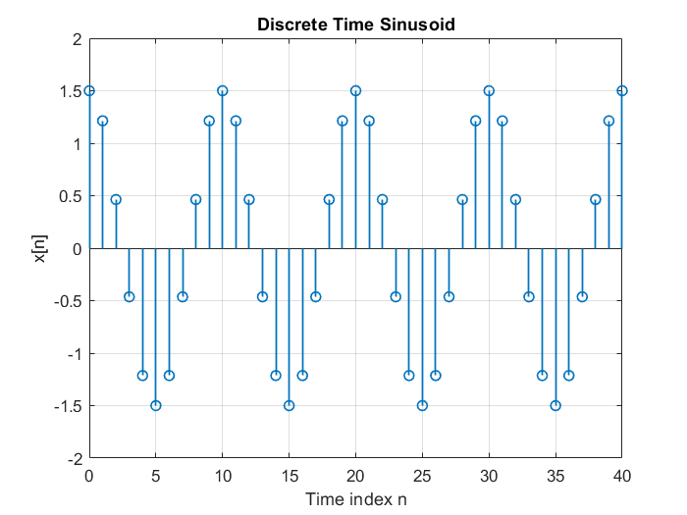

**2b:**

Part ‘b’ asks to find the length of the signal plotted above. To do that I used the *length()* function built into MATLAB.

%b

l = length(xn) % signal length

fprintf('The length of the signal is %d \n', l )

**Output:**

l =

41

The length of the signal is 41

**2c:**

To solve this part of the problem, I used the built-in *max()* function to find the maximum value of the signal defied in the variable *xn*. The variable called *indices* stores all the occurrences of the maximum value in a vector with the help of the *find()* function. I later find the sum of all the samples present between two maxima sum(abs(indices(1) - indices(2))). This allows me to find the number of samples which make up the fundamental period of the discrete-time signal *xn*.

Alternatively, one can use the “Signal Processing toolbox” addon to MATLAB, which includes the functionality for signal processing. I used the function *findpeaks()* which finds the local maxima (peaks) of the signal vector.

(MATLAB documentation: <https://uk.mathworks.com/help/releases/R2024b/signal/ref/findpeaks.html>). The function *findpeaks()* was introduced in Signal Processing Toolbox in R2007b

MATLAB code below:

 %c

% The fundamental period can be calculated by finding the difference between the local maxima of the signal.

% Later count the number of samples from crest to crest

maxYValue = max(xn);

indices = find(xn == maxYValue); % Get all indices where max value occurs

if length(indices) > 1

xValues = sum(abs(indices(1) - indices(2))); % Difference of first two occurrences of the maximum

else

xValues = indices; % If only one occurrence, return the index itself

end

fprintf("The fundamental period is %d samples \n",xValues)

% Alterantively, simply count the number of samples present in the signal

% from crest to crest.

The value of the fundamental period is stored in the *xValues* variable. This number can also be calculated by simply counting the number of individual samples present between two crests.

**2d:**

The final point asks to describe the purpose of the *grid()* function in MATLAB.

The purpose of the *grid()* function is to display a grid inside a given figure in order to improve visualization.

**Problem 3 – Sine signal (discrete-time):**

Problem 3 the task is to use MATLAB to generate and plot the discrete-time signal   
x[n] = sin(ω0n) for the following values of ω0:

-29π/8, -3π/8, -π/8, π/8, 3π/8, 5π/8, 7π/8, 9π/8, 13π/8, 15π/8, 33π/8, and 21π/8

The main challenge I faced when solving the problem was automatically processing the values of ω0 to generate consecutive sin plots and visualize them aesthetically. I used a for loop to generate a sine function for every value k in the list of values above. The I used the if statement to display the plots in groups of 4 on separate figures.

The corresponding MATLAB code is provided below.

 clc, clearvars

% P3a

% Use MATLAB o generate and plot the discrete-time-signal x[n] = sin(wn)

% for the following values of w:

% -29pi/8, -3pi/8, -pi/8, pi/8, 3pi/8, 5pi/8, 7pi/8, 9pi/8, 13pi/8,

% 15pi/8, 33pi/8, and 21pi/8 .

n = 0:63; % discrete-time domain

k_values = [-29, -3, -1, 1, 3, 5, 7, 9, 13, 15, 33, 21];

numPlots = length(k_values);

plotsPerFigure = 4; % We want a 4x1 grid in each figure

for i = 1:numPlots

% Open a new figure every time we start a new group of 4 plots

if mod(i-1, plotsPerFigure) == 0

figure;

end

% Determine subplot index within the current figure (1 to 4)

subplotIndex = mod(i-1, plotsPerFigure) + 1;

subplot(plotsPerFigure, 1, subplotIndex);

% Compute the angular frequency and the corresponding sinusoid

w = k_values(i) * pi/8;

x = sin(w * n);

% Plot the sinusoid using stem

stem(n, x, 'LineWidth', 1);

title(sprintf('%d\\pi/8', k_values(i)));

xlabel('Time index n');

ylabel('x[n]');

axis([min(n), max(n), -2, 2]);

grid on;

end

% After analyzing the visualizations, I concluded that the graph of the

% sinusoid changes its shape every 2𝜋/8 of a rotation.

% The signal repeats (i.e. is periodic) when the argument of the sine

% increases by a multiple of 2𝜋.

% The graphs repeat every 2*k*𝜋 rotations where k = 8.

The code outputs the following figures:

Fig 5.

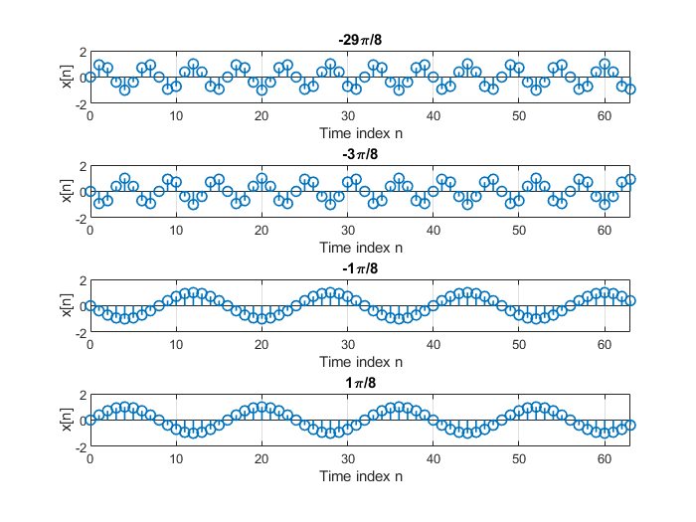

Fig 6.

Fig. 7

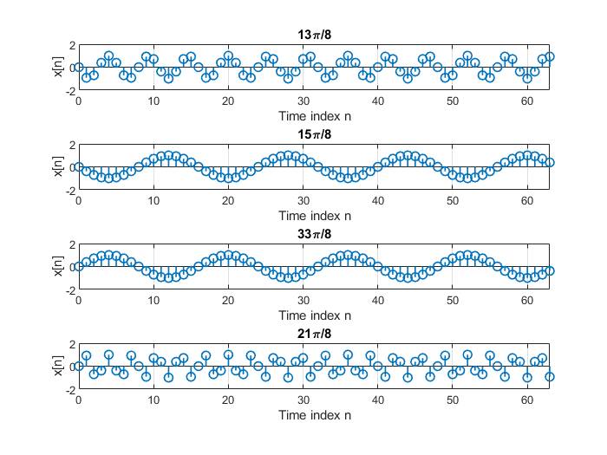

The questions in problem 3 were:

1. Are any of the graphs from the above part identical to one another?
2. How are the graphs of x[n] = sin(ω0n) for ω0 = 7π /8 and ω0 = 9π /8 related?

**Answers:**

**Question 1:**

The graphs are identical for the following pairs of arguments: (-π/8, 15π/8); (π/8, 33π/8);

(-29π/8, 3π/8) ;(5π/8, 21π/8) ;(-3 π/8, 13 π/8) and (1 π/8, 33 π/8).

Since the fundamental period for a sinusoid is 2*π, in our case the function’s shape repeats every 2*k*π/8 where k = 8.

**Question 2:**

Relationship Between sin(7π/8) and sin(7π/8)

1. Calculate the difference between the two angles:

9π/8 − 7π/8 = 2π/8 = π/4

This shows that the two angles are separated by π/4 in terms of frequency, but we need to analyze their phase relationship.

1. Using trigonometric identities:  
   We express the angles in terms of π radians:

**For sin(7π/8):**

sin(7π/8) = sin(π−π/8)

Using the identity:

**sin(π−θ) = sin(θ)**

sin(7π/8) = sin(π/8)

**For sin(9π/8):**

sin(9π/8) = sin(π+π/8)

Using the identity:

**sin(π+θ) = −sin(θ)**

sin(9π/8) = −sin(π/8)

**Conclusion:**

Since,

sin(7π/8) = sin(π/8) and sin(9π/8) = −sin(π/8)

it follows that:

sin(9π/8) = −sin(7π/8)

This means the two functions are negatives of each other, which corresponds to a 180° phase shift (or a sign flip).

Due to the 180° phase shift the **amplitude** has flipped sign, but the **magnitude** remains the same.

**Problem 4 – Sine signal (discrete-time):**

In the final problem, the code provided in the description generated the following graphs:

Fig. 8

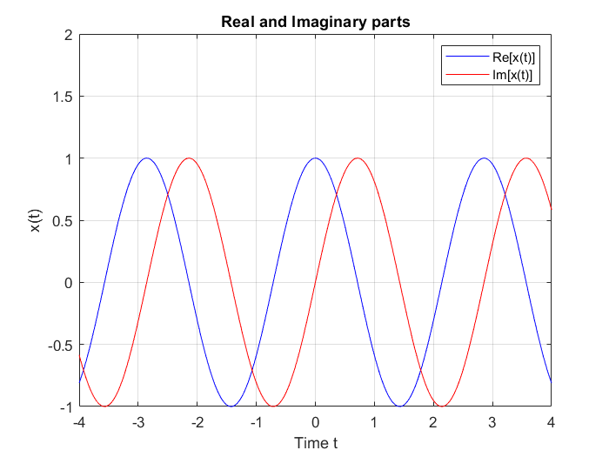

Fig. 9

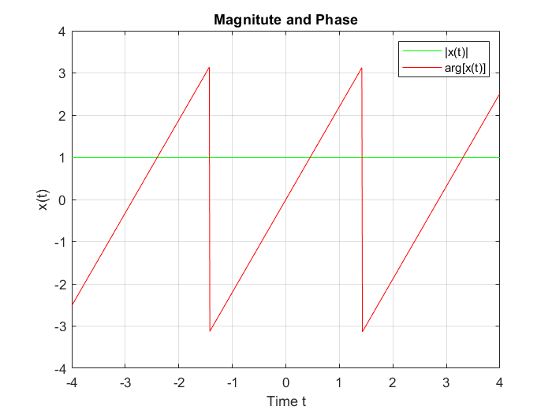

The second part of the problem asks us to use similar MATLAB statements to generate the continuous-time damped exponential signal:



for 0 ≥ t ≥ 4.

and to plot its magnitude and phase.

The code I used to solve this problem is provided below:

 % % P4a cont.

clc, clearvars

% New signal xt_2

t_2 = 0:0.01:4; % new time domain

w2 = 8; % new fequency

xt_2 = 3 .* exp(- t_2 ./2 ) .* exp(1i*w2*t_2) % new complex signal

xt_2R = real(xt_2);

xt_2I = imag(xt_2);

figure(3); % Open new figure

plot(t_2, xt_2R, '-b'); % '-b' means 'solid blue line'

axis([-4, 4, -1, 2]);

grid on;

hold on; % add more curves to the same graph

plot(t_2, xt_2I, '-r'); % solid red line

title('Real and Imaginary parts');

xlabel('Time t_2');

ylabel('x(t_2)');

legend('Re[x(t_2)]', 'Im[x(t_2)]');

hold off;

mag2 = abs(xt_2);

phase2 = angle(xt_2);

figure(4);

plot(t_2, mag2, '-g'); % solid green line

grid on;

hold on;

plot(t_2, phase2, '-r'); % solid red line

title('Magnitute and Phase');

legend('|x(t_2)|', 'arg[x(t_2)]');

xlabel('Time t_2');

ylabel('x(t_2)');

hold off;

The code defines the new complex signal in the variable xt_2 and generates the graphs of the signal as well as the signal’s phase and magnitude.

The graphics are shown below:

X(t2) = 3e-t/2ej8t

Fig. 10

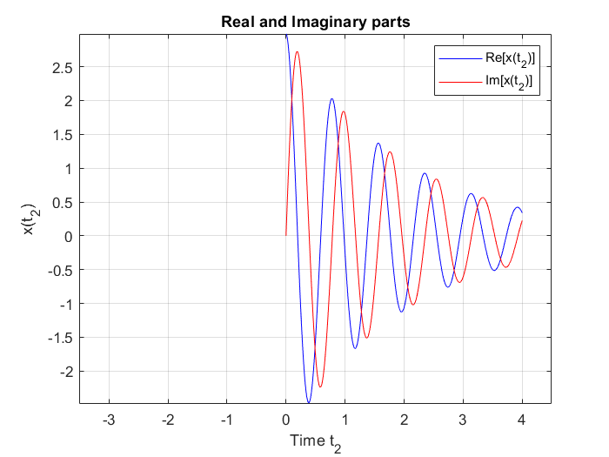

Fig. 11

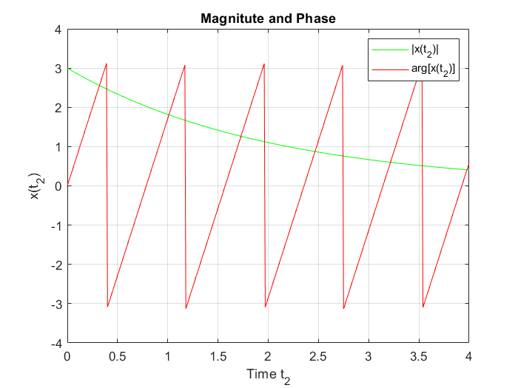

This concludes the final problem in the assignment.

**Conclusion:**

When working out the solutions to the problems given in the assignment, I used MATLAB’s documentation extensively to look up several built-in functions provided in the base version of MATLAB (v. 2024b). I decided to use the MATLAB “Signal Processing toolbox” addon in problem to simplify the code and improve readability. The problem I struggled most with was problem 3 where I needed to come up with a way to generate the corresponding sinusoidal plots automatically for all the arguments provided and correctly explain my solution.

Krzysztof Smykla (album nr.: 417410)